Advice Letters
(10 points)

Think about all of the problems, big and small, the main character(s) ran into in the book. You will write two different letters to an advice column person (made up or otherwise) asking for advice about different problems encountered by the character(s) in the story. These letters may be from two different characters or just the main character. Not only will you need to write asking for advice, you will also need to answer those letters with some advice as if you are the person who writes the advice column.
Make sure your letters include the following
- Greeting (Dear_______,)
- Name of the person to whom you are writing
- A description of the problem (this should take more than 2 sentences)
- Asking for advice about that problem
- Giving good advice from the advice-giver (at least 2-3 sentences)
- Closing (Sincerely; Thank you; Yours truly; etc.)
- Signature (your name)
Letters must be neatly written on loose-leaf paper or typed.

RUBRIC:
Full points will be awarded if all 4 letters are written correctly and neatly.
Points will be taken off as follows:
-2½ points per letter missing letter
- 1-2 points for each letter less than 5 sentences long
- ½ point for each missing part per letter (from the bulleted points above)
- ½ -2 points for sloppiness per letter (If I can’t read it, I can’t grade it.)
- ¼ to ½ point per improper punctuation, spelling, and grammar (each instance)

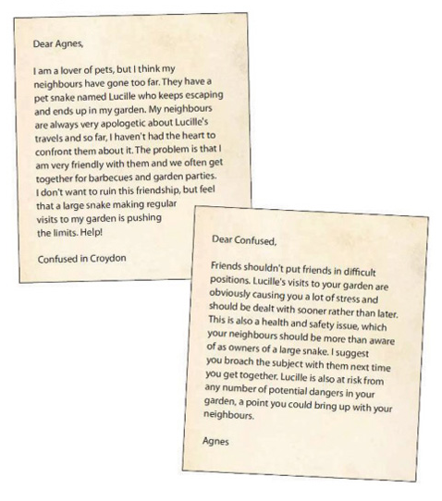

Example of
Letter Asking for Advice
and Letter of Advice

