Book Jacket
(10 points)

Think about creating a book jacket/cover for the book you read. Take a look at the book cover on the book you read. You are going to create an original book jacket. This means that the picture on the front will be something you came up with to represent the book; the summary will be your thoughts and words; the note about the author will be your wording of information you’ve found about him/her.

The book jacket must include:
- the title of the book (spelled and capitalized correctly)
- author’s name (spelled and capitalized correctly)
- a design/illustration for the front cover
- an original summary/book blurb (5-15 sentences)
- a note about the author (5-8 sentences)

Choose at least one extra:
- review from 2-3 newspapers/critiques
- picture of setting or author
- quote from main character
- anything else you think would be appropriate.

Please make sure the information/pictures are well-spaced on the book jacket so that it is neat and pleasing to look at.
Make sure to use color, write neatly, and place all pictures and writing so that “blank space” is minimized.

RUBRIC:
Full points will be awarded if the book jacket is original, neatly depicted, and appropriate to the book.
Points will be taken off as follows:
-2 points for missing/incorrect title and/or author
-1 ½ points for non-original, inappropriate, or missing picture/design
-1 ½ points for non-original, inappropriate, or missing book summary
-1 ½ points for non-original, inappropriate, or missing note about the author
-1 ½ points for non-original, inappropriate, or missing “other” piece
- ½ -5 point(s) for incorrect spelling, punctuation, grammar
- ½ -3 point(s) for sloppiness, too much blank space, out of alignment, etc.

PLEASE DO NOT INCLUDE THIS PAGE WHEN YOU TURN IN YOUR BOOK JACKET
HELPFUL HINTS

When you fold your paper for your book jacket, you have two options: create flaps by folding or create flaps by “drawing” the flaps.

The following is a good way to make sure you have used space well:
- Front: title, author, design/illustration depicting the story
- Back: original summary OR note about the author
- Front Inside Flap: original summary OR note about the author OR “other” piece
- Back Inside Flap: note about the author OR “other” piece

If you fold the cover to have flaps, when you unfold it, this will be the format:
back inside flap  Note about the author  Or  “other” piece | BACK  Original Summary  (an actual summary of the ENTIRE story, not just an attention grabber)  Or  Original note about the author | Title of Book Author’s Name | FRONT  Title of Book  original  design/illustration  depicting  the story  Author’s Name | front inside flap  Original summary  Or  Note about the author  Or  “other” piece

- Make sure to COLOR your entire cover. Do not use dark colors for the background because the writing will be difficult to read.
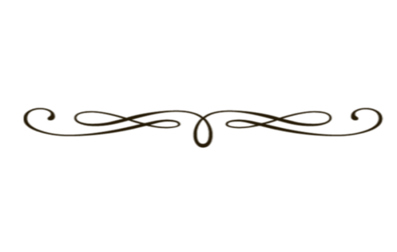
- Make sure to “center” your writing both vertically and horizontally. If you have quite a bit of blank space above and below a section of writing, you could always draw “dividers” such as
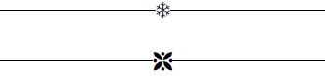

or you could draw simple pictures that would be representative of parts of the book (characters, pieces of setting, important items, etc.).
- You may use a blank piece of printer paper or the paper available in my classroom for the book jackets. Please do not use poster board or laminate the cover. Simple paper is all that is required.

